In this article, we are going to demonstrate how to implement a neural network from scratch by building a digit recognizer using MNIST dataset. MNIST dataset is a large dataset of handwritten digits of dimensions 28x28. Below is a sample taken form MNIST dataset.

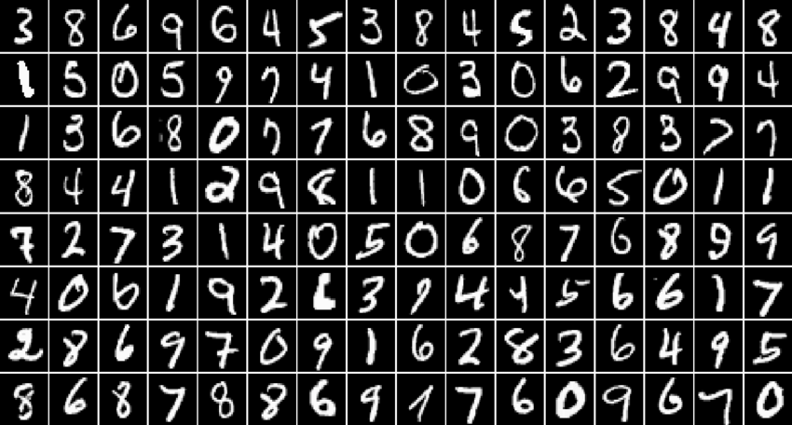

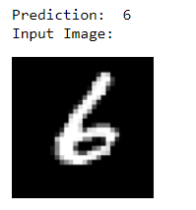After the model is developed and trained, the model will be able to predict handwritten digits from 0-9 from image provided by us. The output will be as below:

**Model Architecture**

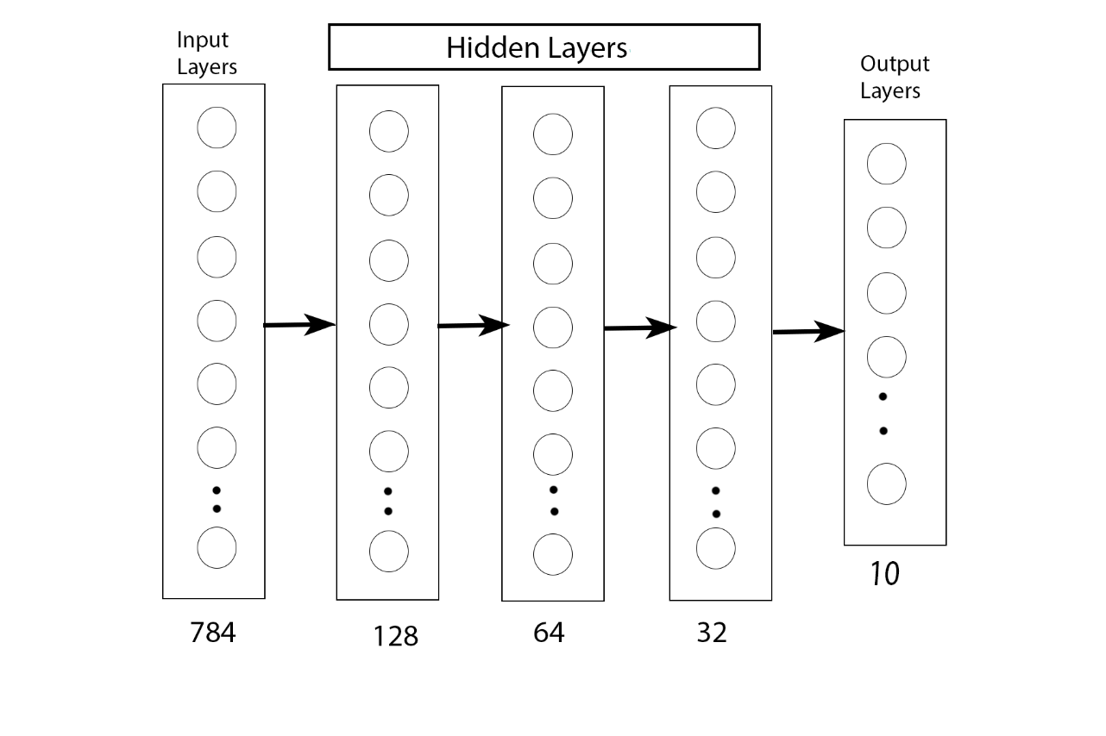

As one input in MNIST dataset is of shape 28x28(784) pixels, we take 784 inputs in the input layers. As we have 10 digits (0-9), this is a multiclass classification task, so we have 10 outputs in the output layers. The overall architecture is [784,128,64,32,10]. Relu Activation fuction is used in the hidden layers, and softmax activation function is used in output layer as it is a classification task.

**Libraries**

Let us implement all the required components of the neural network. The libraries used are numpy to perform mathematical operations, matplotlib will be used to plot the graph of the costs and pillow will be used to import the image from user provided path.

import numpy as np

import PIL

import matplotlib.pyplot as plt

**Initialize Weights and Biases**

Let us define a function to initialize the all the parameters i.e. weights and biases. The weights are initialized using He approximation(i.e W[l] = np.random.randn(shape)*np.sqrt(2/n[l-1] , l is the layer in NN, and n is number of nodes in the layer) and biases are initialized to 0.

def initialize_parameters_deep(layer_dims):

np.random.seed(1)

parameters = {}

L = len(layer_dims)

for l in range(1,L):

parameters['W' + str(l)] = np.random.randn(layer_dims[l], layer_dims[l-1]) * np.sqrt(2/layer_dims[l-1])

parameters["b"+str(l)]=np.zeros((layer_dims[l],1))

return parameters

**Activation Functions**

The activation functions we will be using are softmax and relu.

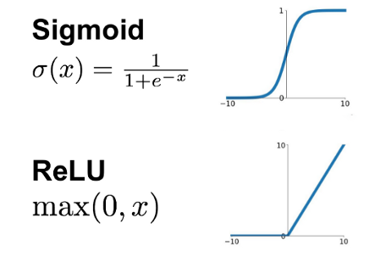

Let us the define relu and softmax along with their derivatives.

**Relu**

def relu(x):

x = np.maximum(0,x)

return x

**Relu_Prime**

def relu_prime(x):

x[x<=0] = 0

x[x>0] = 1

return x

**Softmax**

def softmax(x):

ans = np.exp(x)/np.sum(np.exp(x),axis=0)

return ans

**Softmax_Prime**

def softmax_prime(x):

ans = softmax(x)*(1-softmax(x))

return ans

**Forward Propagation**

Let us define the helper functions required for the forward propagation task

Let us define a linear_forward layer function with calculates z = w*a+b in a layer of neural network.

def linear_forward(A,W,b):

Z=W.dot(A)+b

cache = (A, W ,b)

return Z,cache

Here A is the activations from previous layer, W is weight numpy array of size (size of current layer,size of previous layer), b is bias numpy array of size (size of current layer, 1) and cache is tuple of (A,W,b) which will be used during backpropagation

Now we will implement deep_layer which will calculate the activations according to the defined activation function as:

def deep_layer(A,W,b,activation):

Z,linear_cache = linear_forward(A,W,b)

if activation == 'softmax':

A = softmax(Z)

activation_cache = Z

elif activation == 'relu':

A = relu(Z)

activation_cache = Z

cache = (linear_cache,activation_cache)

return A,cache

Here cache contains linear_cache(A,W,b) from linear_forward and activation_cache(Z) , which are going to be used during the back propagation.

Now let us use the above functions and implement forward propagation as:

def forward_pass(input_X,parameters):

caches=[]

depth = int(len(parameters)/2) # number of layers in the neural network

A = input_X

for l in range(1,depth):

A_prev = A

A,cache = deep_layer(A_prev,parameters['W'+str(l)],parameters['b'+str(l)],'relu')

caches.append(cache)

A_last,cache = deep_layer(A,parameters['W'+str(depth)],parameters['b'+str(depth)],'softmax')

caches.append(cache)

return A_last,caches

Here A_last is the output of the neural network after passing through all layers and caches is the list of all the cache(A,W,b,Z) of each layer of neural network.

Thus, forward propagation part is complete

**Cost Computation**

Since this is a multiclass classification task, the loss function we use is categorical cross-entropy

L $L(y,\hat{y})=-\sum_{i=1}^{n}{y_{i}\log{{\hat{y}}_{i}}}$

So, the cost is calculated as

- )

Now, lets write a function to compute cost as:

def compute_cost(AL,Y):

Y= np.reshape(Y,(Y.shape[0],Y.shape[1]))

m = Y.shape[1]

cost =(-1/m)*(np.multiply(Y,np.log(AL))) #categorical_cross_entropy

cost = np.squeeze(cost)

return cost

**Backpropagation**

In backpropagation we have to calculate the gradients so as the update the weight and bias parameters across the network using loss generated by the loss function at output layer. After calculating 𝑑𝑍[𝑙]=∂L/∂𝑍[𝑙], we have to calculate 𝑑𝑊[𝑙],𝑑𝑏[𝑙],𝑑𝐴[𝑙−1] as

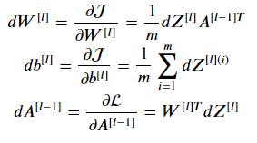

Let us write helper function to calculate the gradients as below

def linear_backward(dZ,cache):

A_prev , W, b = cache

m = A_prev.shape[1]

dW = (1/m)*np.dot(dZ,A_prev.T)

db = (1/m)*np.sum(dZ,axis=1,keepdims=True)

dA_prev = np.dot(W.T,dZ)

return dA_prev, dW, db

def backward_activation(dA, cache, activation):

linear_cache,activation_cache = cache

if activation == "relu":

dZ = dA*relu_prime(activation_cache)

dA_prev, dW,db = linear_backward(dZ,linear_cache)

elif activation == "softmax":

dZ = dA

dA_prev, dW,db = linear_backward(dZ,linear_cache)

return dA_prev, dW, db

In case of softmax at the output layer, to avoid the division by zero during gradient calculation in backward pass, we compute dz = A_last-Y before hand send it to the backward_activation function as dA_last_Z, whereas the dZ for relu is calculated in backward_activation function itself.

Now, let us implement backward pass using the above helper functions.

def backward_pass(A_last,Y,caches):

grads={}

L = len(caches)

m = A_last.shape[1]

Y = Y.reshape(A_last.shape)

dA_last_Z = A_last-Y

current_cache = caches[L-1]

grads["dA"+str(L-1)],grads["dW"+str(L)],grads["db"+str(L)] = backward_activation(dA_last_Z,current_cache,activation='softmax')

for l in reversed(range(L-1)):

current_cache = caches[l]

dA_prev_temp, dW_temp, db_temp = backward_activation(grads['dA'+str(l+1)],current_cache,activation="relu")

grads["dA"+str(l)] = dA_prev_temp

grads["dW"+str(l+1)] = dW_temp

grads["db"+str(l+1)]=db_temp

return grads

Now, after all the gradients have been calculated, we have to updates all the weights and biases across the network as below:

def update_parameters(parameters, grads, learning_rate):

depth = len(parameters) // 2

for l in range(depth):

parameters["W"+str(l+1)] = parameters["W"+ str(l+1)]-learning_rate*grads['dW'+str(l+1)]

parameters["b"+str(l+1)] = parameters["b" + str(l+1)]-learning_rate*grads['db'+str(l+1)]

return parameters

**Compiling the model**

We will be implementing mini batch gradient descent for our model as the dataset is very large, to update the parameters after the training is complete on the particular batch instead of waiting to update the parameters after an epoch like in batch gradient descent.

def mini_batch_gradient_descent(X,Y,layer_dims=[3,2,1],mini_batch_size=8,epochs=100, learning_rate=0.0075):

np.random.seed(1)

m = X.shape[1]

mini_batches = []

#shuffling the data

permutation = list(np.random.permutation(X.shape[1]))

X_shuffled = X[:, permutation]

Y_shuffled = Y[:, permutation]

num_of_complete_batches = m // mini_batch_size

for i in range(num_of_complete_batches):

mini_batch_X = X_shuffled[:,i*mini_batch_size:(i+1)*mini_batch_size]

mini_batch_Y = Y_shuffled[:,i*mini_batch_size:(i+1)*mini_batch_size]

mini_batch = (mini_batch_X,mini_batch_Y)

mini_batches.append(mini_batch)

#if there is incomplete batch

if m % mini_batch_size != 0:

mini_batch_X=X_shuffled[:,num_of_complete_batches*mini_batch_size:num_of_complete_batches*mini_batch_size + (m - mini_batch_size*num_of_complete_batches)]

mini_batch_Y=Y_shuffled[:,num_of_complete_batches*mini_batch_size:num_of_complete_batches*mini_batch_size + (m - mini_batch_size*num_of_complete_batches)]

mini_batch = (mini_batch_X,mini_batch_Y)

mini_batches.append(mini_batch)

#parameters_initialize

costs=[]

parameters = initialize_parameters_deep(layer_dims)

for j in range(epochs):

for mini_batch in mini_batches:

x_batch,y_batch=mini_batch

# parameters = parameters

A_Last,caches = forward_pass(x_batch,parameters)

cost = np.sum(compute_cost(A_Last, y_batch))/A_Last.shape[0]

grads = backward_pass(A_Last, y_batch , caches)

parameters = update_parameters(parameters, grads, learning_rate)

if j%2 == 0:

print(f'Iteration {j} : {cost}')

costs.append(cost)

return parameters,costs

**Loading The DataSet and Preprocessing**

Now, lets download the MNIST dataset to train our model.

from sklearn.datasets import fetch_openml

X, y = fetch_openml('mnist_784', version=1, return_X_y=True)

Let us define one hot encoding function to convert the output into one hot vector.

def one_hot(y, depth):

one_hot_list = np.array([],dtype=int)

for i in range(depth):

temp =np.zeros((1,depth),dtype=int)

temp[0][i]=1

one_hot_list =np.append(one_hot_list,temp)

one_hot=np.reshape(one_hot_list,(depth,depth))

y = one_hot[y].T

return y

We will separate the dataset into train set and test set.

train_x = X[0:60000]/255.0 #normalizing the data

train_x=train_x.T

train_y = y[0:60000]

train_y = train_y.astype(int)

train_y= np.reshape(train_y,(1,60000))

test_x = X[60000:X.shape[0]]/255.0 #normalizing the data

test_x=test_x.T

test_y = y[60000:y.shape[0]]

test_y = test_y.astype('int')

Converting the train output into one hot encoding using above function

train_y = one_hot(train_y,10)

The data is now in shape:

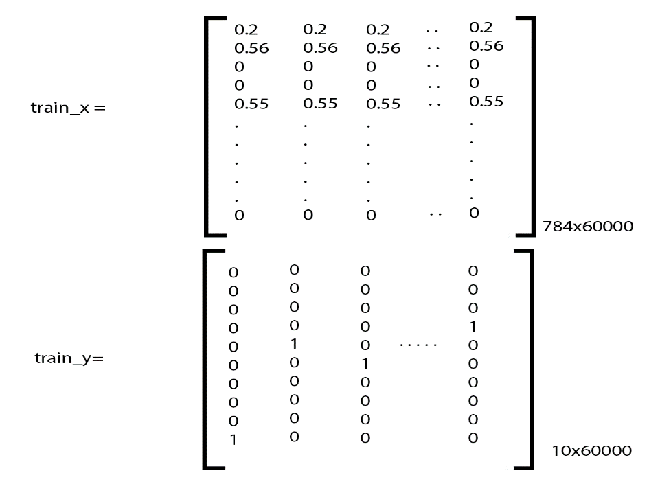

Each column denotes one training example in the dataset.

**Running the model:**

The below command runs the trains the model.

parameters,costs=mini_batch_gradient_descent(train_x, train_y,layer_dims=[784,128,64,32,10],mini_batch_size=64,epochs=40)

The graph showing the cost can be plotted as:

plt.plot(costs)

plt.ylabel('Cost')

plt.xlabel('Iterations per 2 epochs')

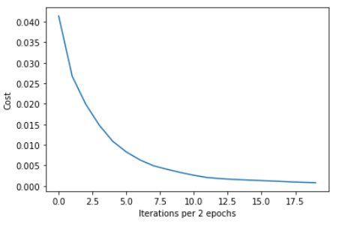plt.show()

**Testing the Model**

The following code passes the test_x through the forward_pass and predict the resut. The test accuracy was found to be 97.29% in our case.

correct = 0

incorrect=[]

for i in range(test_y.shape[0]):

last,_=forward_pass(np.reshape(test_x[:,i],(784,1)),parameters)

if np.argmax(last) == test_y[i]:

correct +=1

else:

incorrect.append(i)

accuracy = correct/test_y.shape[0]

print("Test Accuracy:",accuracy)

**Trying with your own image**

You can try with your own image by changing the path of the image below. Keep in mind the images in the dataset I used had black background and white digits. If the colors are inverted, the neural network will fail to give correct prediction. You can make the model more accurate by using dataset containing both black and white background. However, in our case I have implemented a function called invert_image() which inverts the background of image to black if the background of the image is white and give correct prediction.

# Code to convert the image having white background to black

import PIL.ImageOps

def invert_image(test_img):

I = np.asarray(test_img)

zero_pixels=0

for i in range(I.shape[0]):

for j in range(I.shape[1]):

if I[i,i] == 0:

zero_pixels+=1

non_zero_pixels = 784-zero_pixels

if non_zero_pixels > zero_pixels:

inverted_image = PIL.ImageOps.invert(test_img)

return inverted_image

else:

return test_img

# Try with your own image

from PIL import Image

test_img = Image.open('test_img.jpg') #path of the image

test_img_converted = test_img.convert('L')

test_img_resized = test_img_converted.resize((28,28))

test_img_array=np.asarray(test_img_resized)/255.0

prediction,_=forward_pass(np.reshape(test_img_array,(784,1)),parameters)

predicted_num=np.argmax(prediction)

print("Prediction: ",predicted_num)

print("Input Image: ")

test_img.resize((128,128))

Some of the examples I have tried on are:

